

SIMATS ENGINEERING

Saveetha Institute of Medical and Technical Sciences Chennai- 602105

St Student Name: Sri Shamitha Sivaraj Reg. No.:192320001
Course Code: CSA0202 Slot: c
Course Name: C PROGRAM
Course Faculty: Dr. V. Jayasudha

Project Title: Smart Emergency Patient Coordination and Risk Monitoring System Using C
Module Photographs: The flowchart shows how the problem is analyzed, requirements identified, and the solution designed using an algorithm, pseudocode, and flowchart.
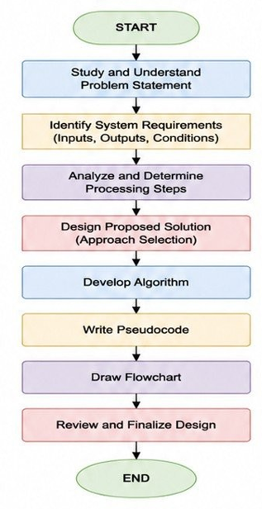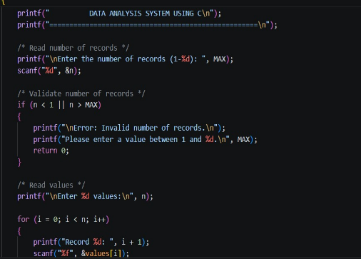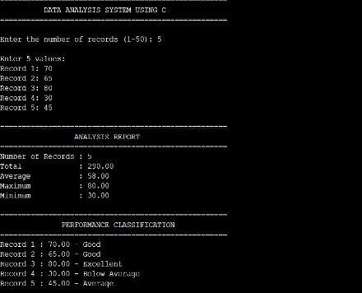

Figure 1 : Flow Chart Figure 2: C Program Code Figure 3: Expected Result
Project Description: Module 1 – Problem Analysis and Design
This phase focuses on understanding and analyzing the problem and defining key system requirements; input and output data, conditions, constraints, and processing stages are analyzed to determine an appropriate solution method. Based on this analysis, a system is designed to provide a clear and structured solution. An algorithm is developed to define the logical sequence of operations required to solve the problem; this algorithm is then represented in pseudocode and flowchart form, facilitating understanding prior to implementation. Finally, the design is verified and approved to ensure all requirements have been properly addressed, serving as the foundation for successful implementation using the C programming language..

Student Signature Guide Signature

